SLO (Service level objective)
Service-level objectives (SLOs) within a Dynatrace monitoring environment on the Service-level objectives page shows important information such as status, error budget and burn rate, target, warning, the number of open problems out of the total number of problems for the SLO entity selector.
Importance of SLO:
1) Improve the software quality.
2) Help with decision making.
3) Avoid downtime.
Types of SLOs:
1) Basic availability
2) Single request availability
3) Service request Response time SLO
4) Synthetic Test SLO
5) Synthetic Test step SLO
6) Real user monitoring SLO
7) Infrastructure capability SLO

1)Basic availability:

Go to new slo option in Dynatrace and click on the Service-level-availability option.
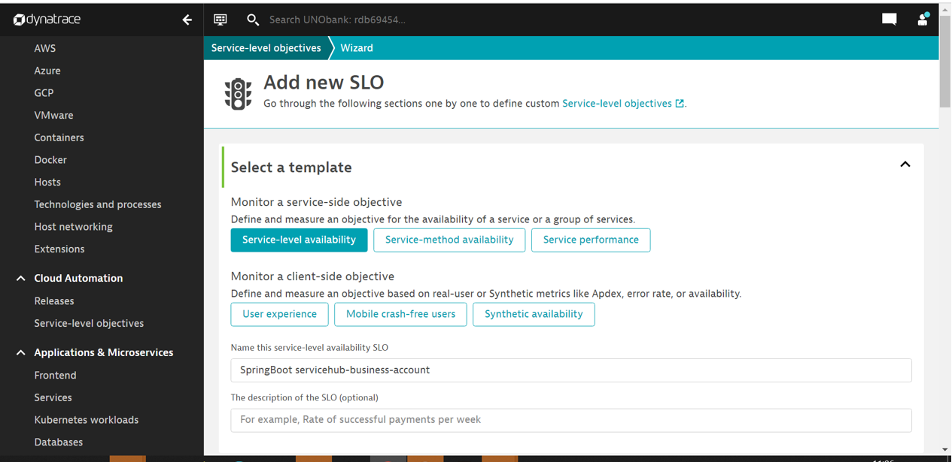
Define the metric according to your requirement, give metric name.
In the below screenshot the fundamental service-level availability is measured by dividing the number of successful service calls (builtin:service.errors.server.successCount ) by the total number of service calls (builtin:service.requestCount.server).
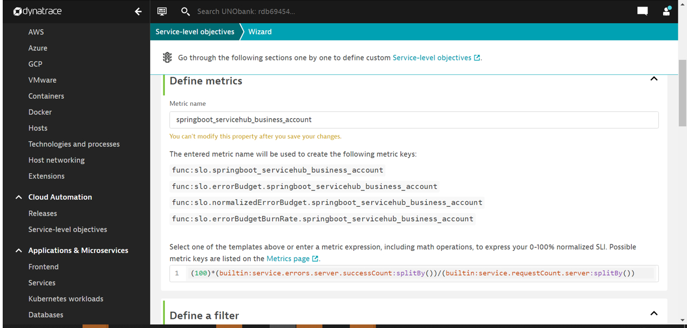
You can define your filter according to the timeline.
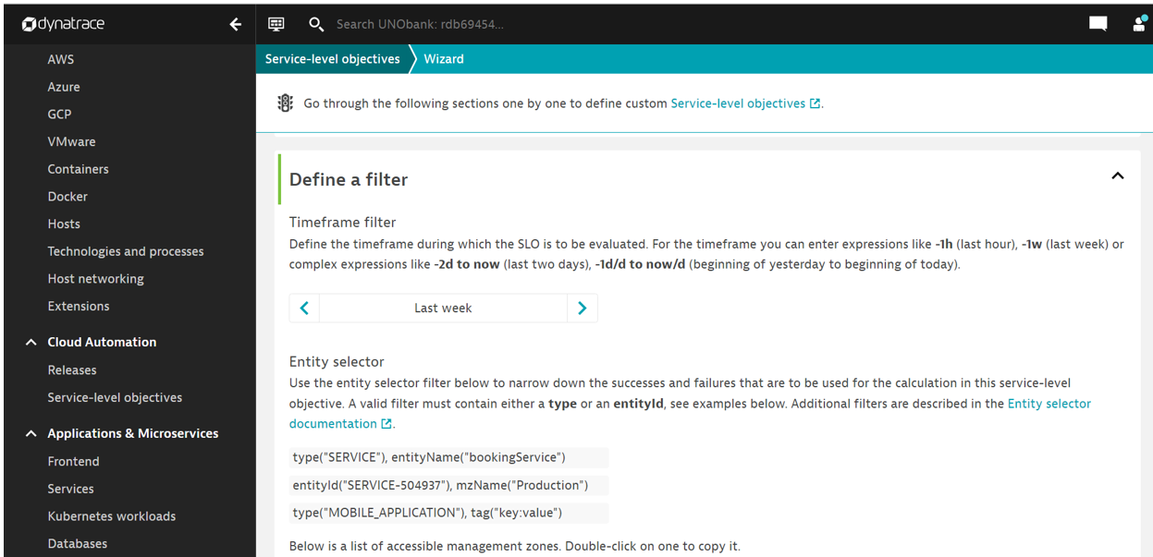
type("APPLICATION"),entityName("My application")
in below screenshot
type("SERVICE"),entityId("SERVICE-B7125EFC9701A146")

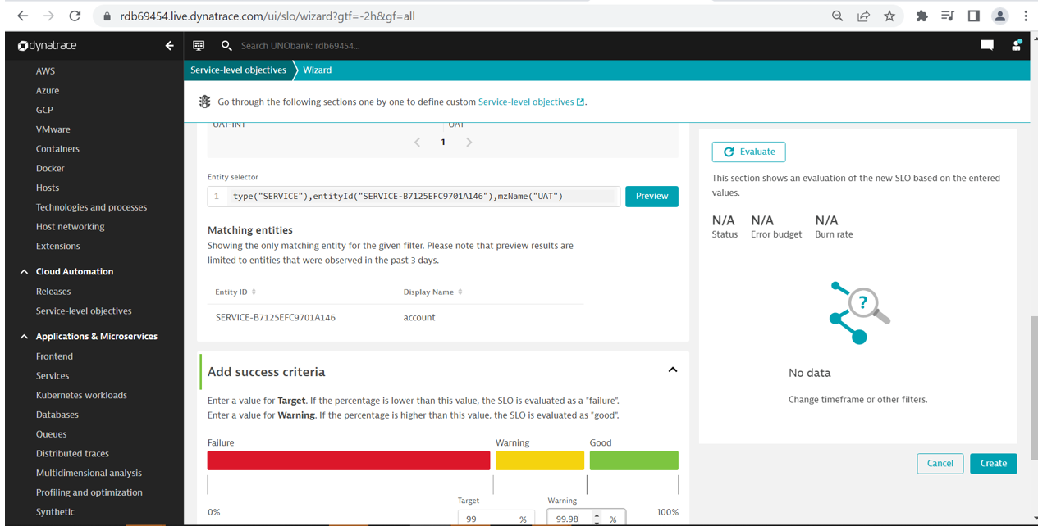

2) Single request availability:
In the below screenshot the fundamental single request availability is measured by dividing the number of successful successfulrecommendation:sum)/total response count.
Based on the data observed in the last 24 hours, this metric will consume 5.26k DDU/year (0.01 DDU/min).

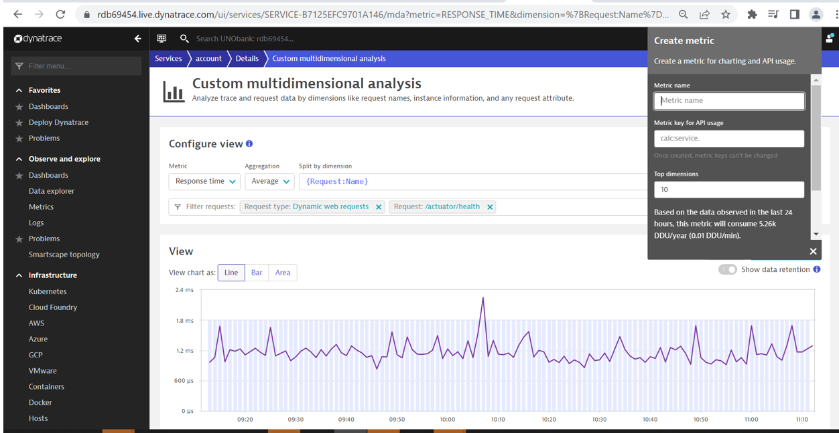
Create metric ID for request count and successful request count
After creating metric copy the key IDs.
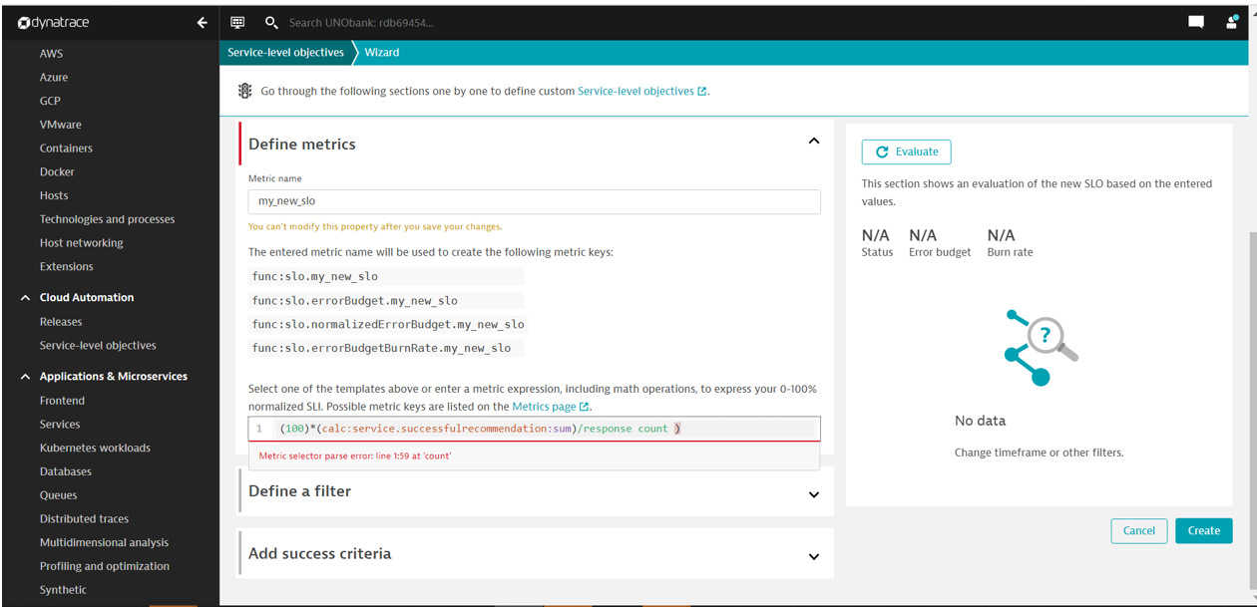
(100) *(calc:service.successfulrecommendation:sum)/total response count )
3) Service request Response time SLO
Go to multidimensional analysis of the service and create metric for the
Total count and acceptable request count metric.

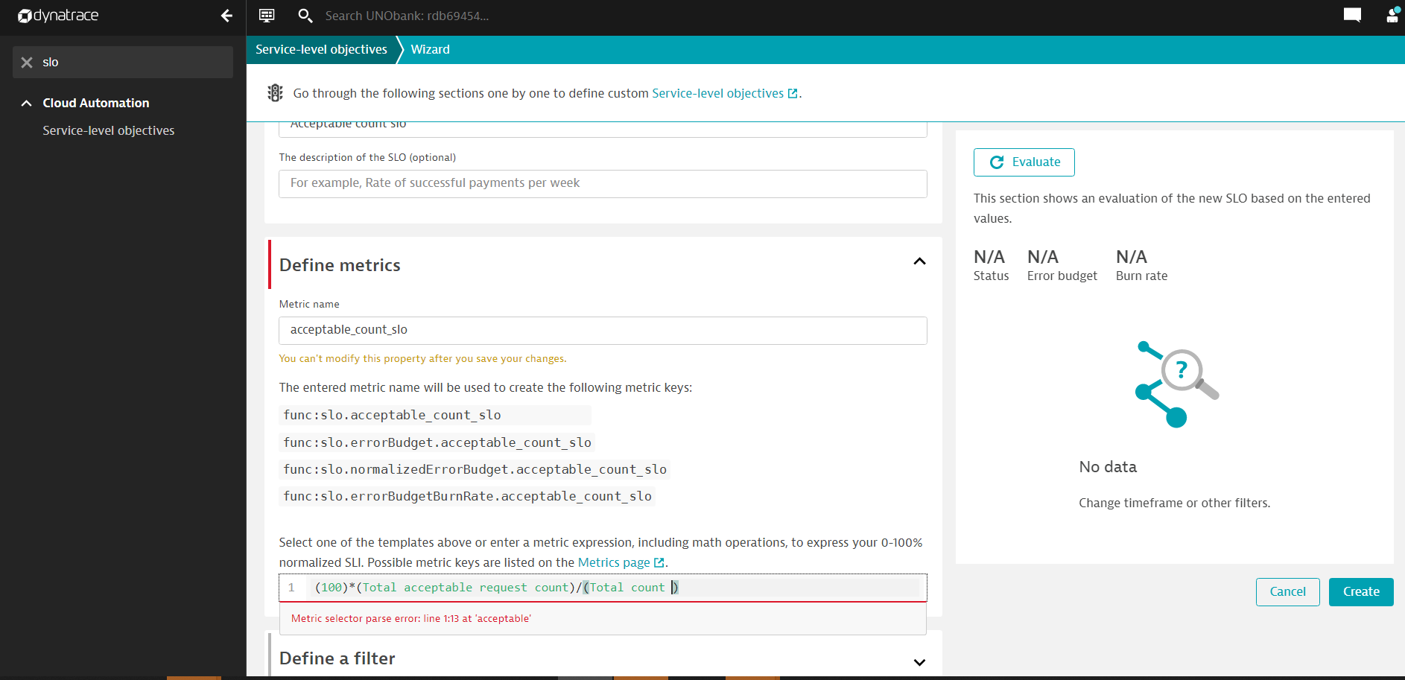
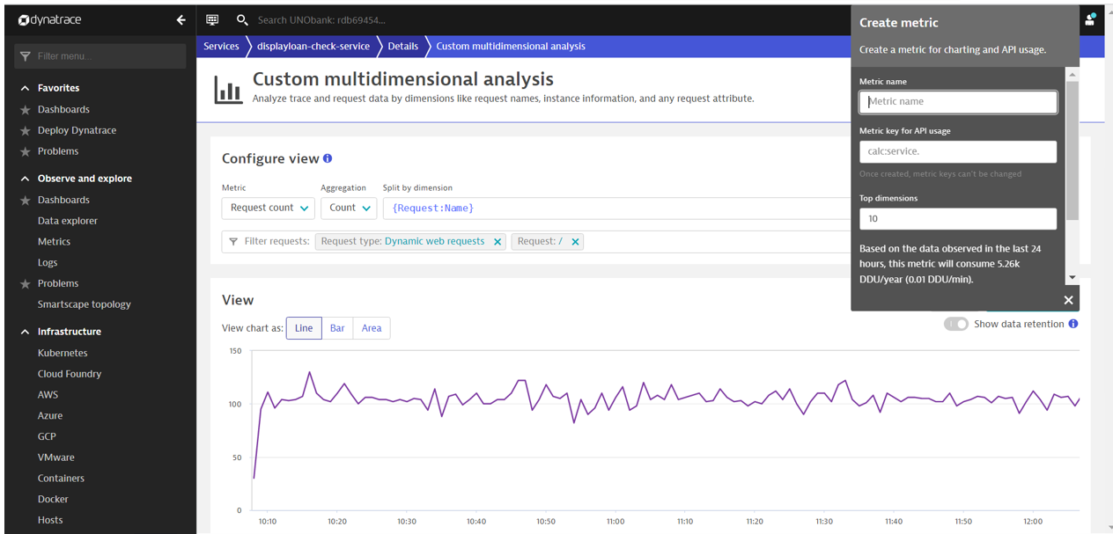
4)Synthetic Test SLO
first need to create synthetic monitor and copy that ID in the entity selector
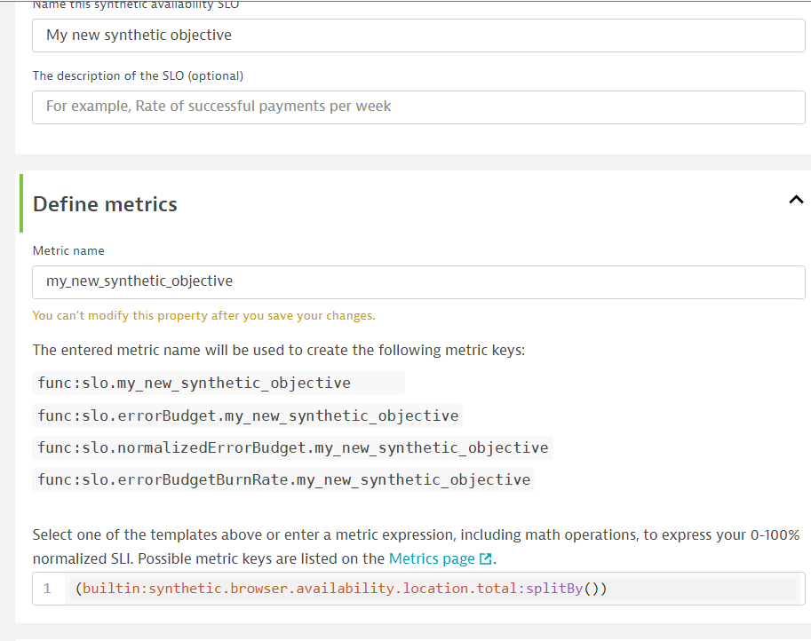
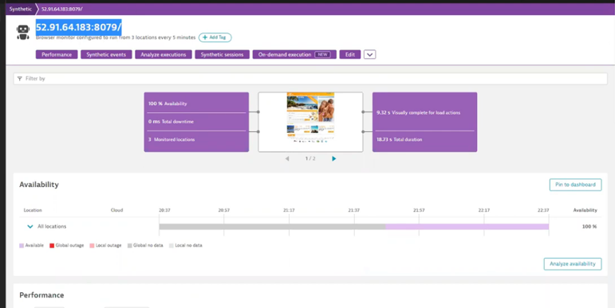
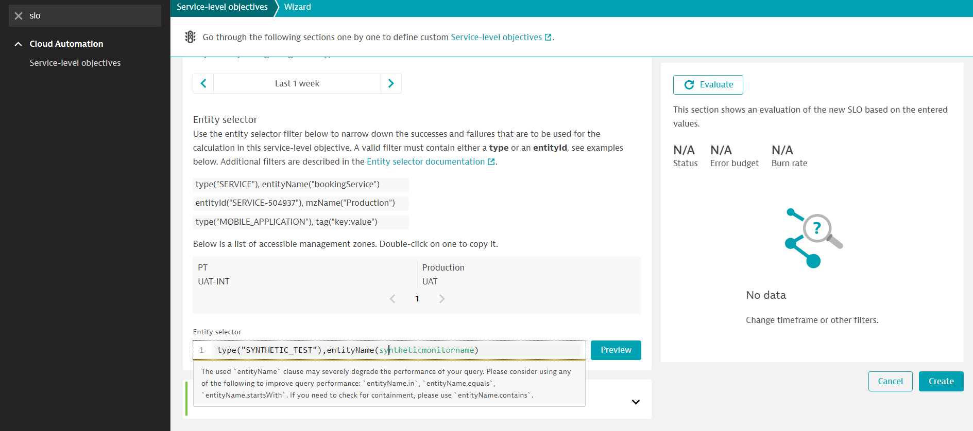
Type(“SYNTHETIC_TEST”),entityID(syntheticmonitorID)

5) Synthetic Test step SLO
SLO, which represents the percentage of successful synthetic monitor executions related to the total number of executions.
Synthetic monitor event ID we need to get from the application browsing event ID. We should put in the filter and apply.
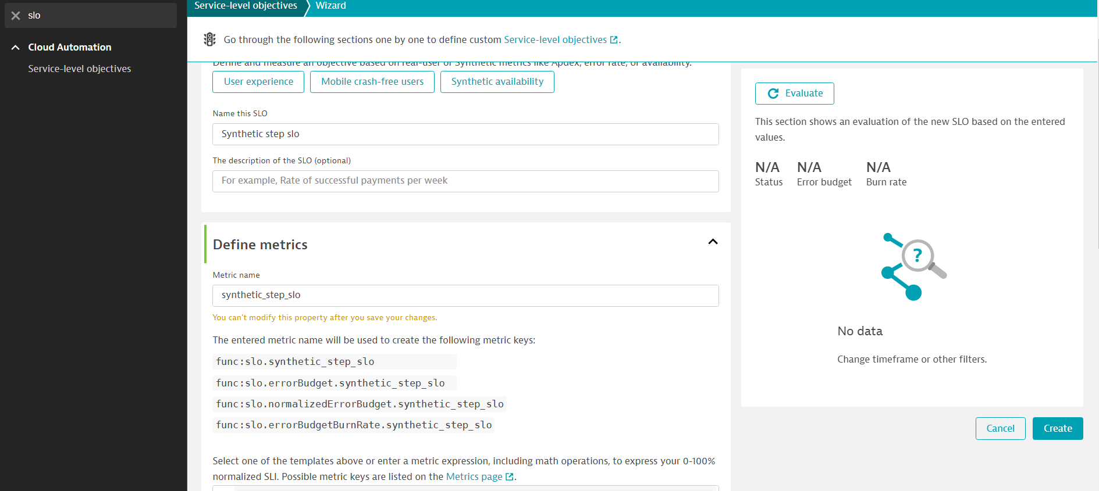
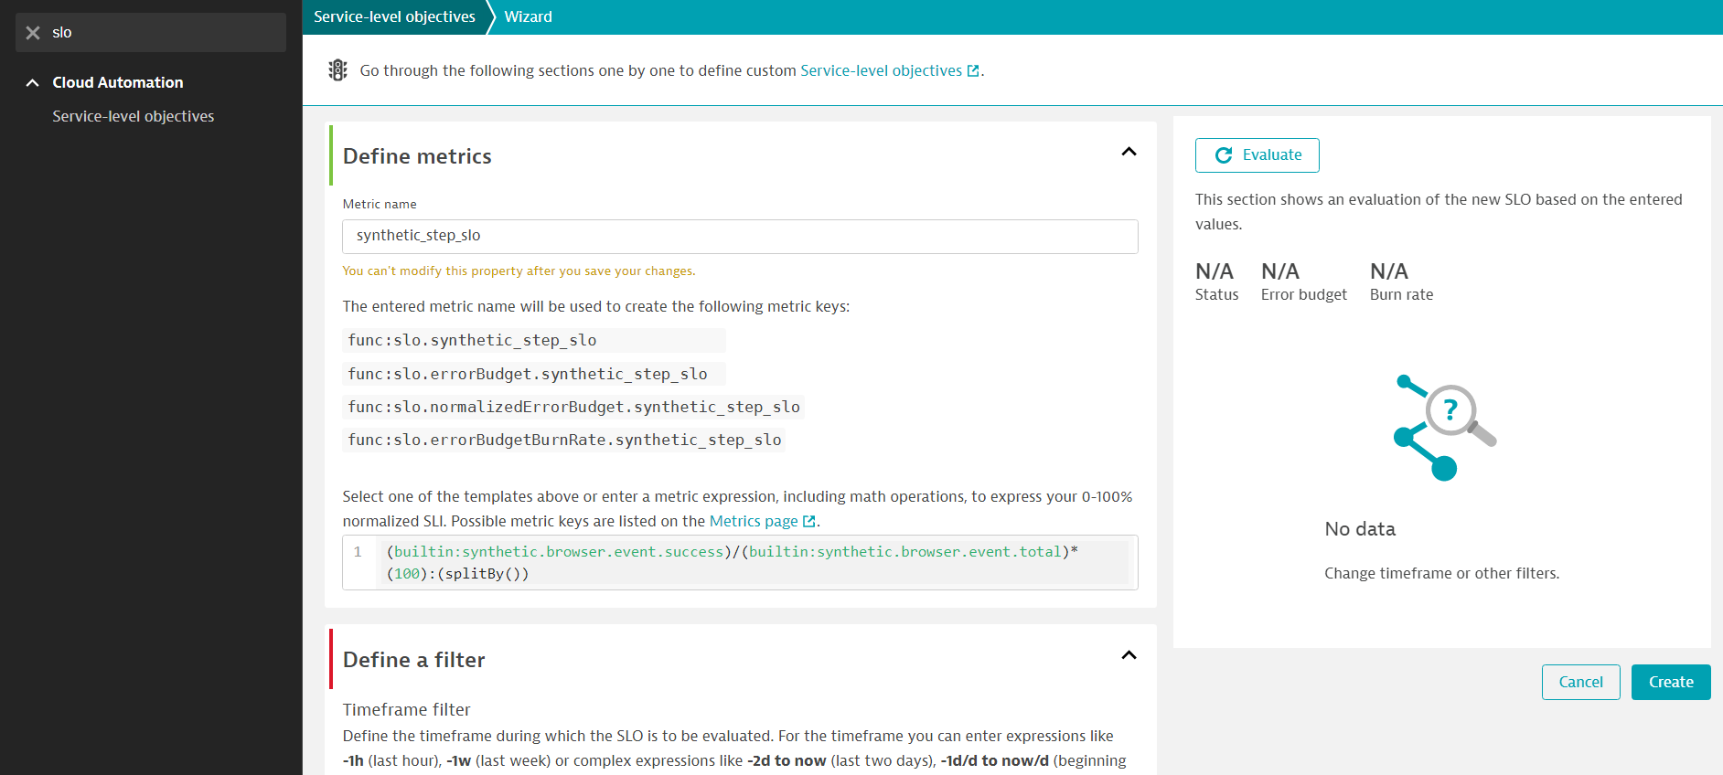
6) Real user monitoring
type("MOBILE_APPLICATION"),entityId("MOBILE_APPLICATION-0F1384D258D7499D")
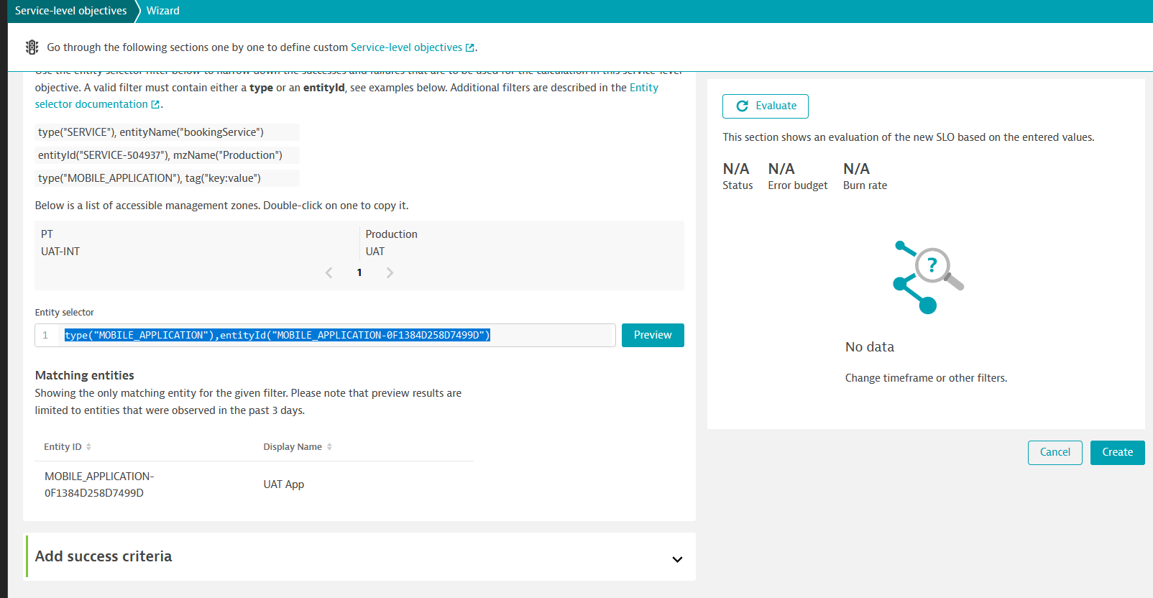
7)Infrastructure capability SLO
If you want to set SLO for CPU usage create metric accordingly and apply.
